### Project description

You're working as an analyst for Zuber, a new ride-sharing company that's launching in Chicago. Your task is to find patterns in the available information. You want to understand passenger preferences and the impact of external factors on rides.

Working with a database, you'll analyze data from competitors and test a hypothesis about the impact of weather on ride frequency.

### Description of the data

A database with info on taxi rides in Chicago:

neighborhoods table: data on city neighborhoods

* name: name of the neighborhood
* neighborhood_id: neighborhood code

cabs table: data on taxis

* cab_id: vehicle code
* vehicle_id: the vehicle's technical ID
* company_name: the company that owns the vehicle

trips table: data on rides

* trip_id: ride code
* cab_id: code of the vehicle operating the ride
* start_ts: date and time of the beginning of the ride (time rounded to the hour)
* end_ts: date and time of the end of the ride (time rounded to the hour)
* duration_seconds: ride duration in seconds
* distance_miles: ride distance in miles
* pickup_location_id: pickup neighborhood code
* dropoff_location_id: dropoff neighborhood code

weather_records table: data on weather

* record_id: weather record code
* ts: record date and time (time rounded to the hour)
* temperature: temperature when the record was taken
* description: brief description of weather conditions, e.g. "light rain" or "scattered clouds"

### Table scheme

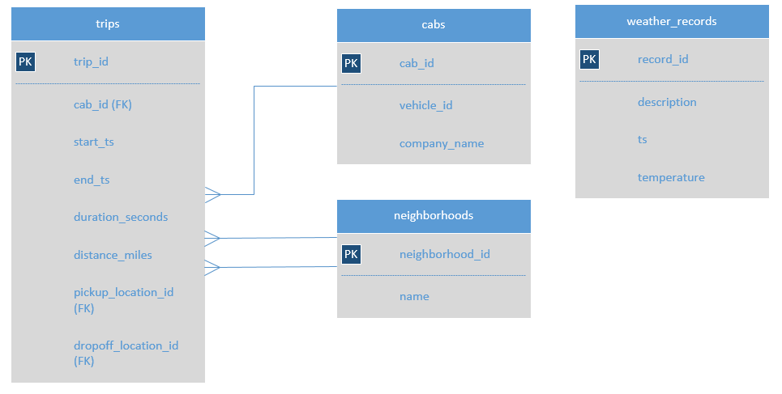

Note: there isn't a direct connection between the tables trips and weather_records in the database. But you can still use JOIN and link them using the time the ride started (trips.start_ts) and the time the weather record was taken (weather_records.ts).

### Instructions on completing the project

**Step 1. Write a code to parse the data on weather in Chicago in November 2017 from the website:**

<https://code.s3.yandex.net/data-analyst-eng/chicago_weather_2017.html>

**Step 2. Exploratory data analysis**

* Find the number of taxi rides for each taxi company for November 15-16, 2017. Name the resulting field trips_amount and print it along with the company_name field. Sort the results by the trips_amount field in descending order.
* Find the number of rides for every taxi company whose name contains the words "Yellow" or "Blue" for November 1-7, 2017. Name the resulting variable trips_amount. Group the results by the company_name field.
* In November 2017, the most popular taxi companies were Flash Cab and Taxi Affiliation Services. Find the number of rides for these two companies and name the resulting variable trips_amount. Join the rides for all other companies in the group "Other." Group the data by taxi company names. Name the field with taxi company names company. Sort the result in descending order by trips_amount.

**Step 3. Test the hypothesis that the duration of rides from the the Loop to O'Hare International Airport changes on rainy Saturdays.**

* Retrieve the identifiers of the O'Hare and Loop neighborhoods from the neighborhoods table.
* For each hour, retrieve the weather condition records from the weather_records table. Using the CASE operator, break all hours into two groups: "Bad" if the description field contains the words "rain" or "storm," and "Good" for others. Name the resulting field weather_conditions. The final table must include two fields: date and hour (*ts*) and weather_conditions.
* Retrieve from the trips table all the rides that started in the Loop (neighborhood_id: 50) and ended at O'Hare (neighborhood_id: 63) on a Saturday. Get the weather conditions for each ride. Use the method you applied in the previous task. Also retrieve the duration of each ride. Ignore rides for which data on weather conditions is not available.

**Step 4. Exploratory data analysis (Python)**

In addition to the data you retrieved in the previous tasks, you've been given a second file. You now have these two CSVs:

project_sql_result_01.csv. It contains the following data:

* company_name: taxi company name
* trips_amount: the number of rides for each taxi company on November 15-16, 2017.

project_sql_result_04.csv. It contains the following data:

* dropoff_location_name: Chicago neighborhoods where rides ended
* average_trips: the average number of rides that ended in each neighborhood in November 2017.
* For these two datasets you now need to:
* import the files
* study the data they contain
* make sure the data types are correct
* identify the top 10 neighborhoods in terms of drop-offs
* make graphs: taxi companies and number of rides, top 10 neighborhoods by number of dropoffs
* draw conclusions based on each graph and explain the results

**Step 5. Testing hypotheses (Python)**

project_sql_result_07.csv — the result of the last query. It contains data on rides from the Loop to O'Hare International Airport. Remember, these are the table's field values:

* start_ts — pickup date and time
* weather_conditions — weather conditions at the moment the ride started
* duration_seconds — ride duration in seconds

Test the hypothesis: "The average duration of rides from the Loop to O'Hare International Airport changes on rainy Saturdays."

Set the significance level (alpha) value on your own.

Explain:

* how you formed the null and alternative hypotheses
* what criterion you used to test the hypotheses and why

## How will my project be evaluated?

Here are the project assessment criteria. Read them over carefully before you get to work.

Here’s what the project reviewer will look for when assessing your project:

* how you retrieve data from the website
* how you make data slices
* how you group data
* whether you use the the right methods for joining tables
* how you formulate hypotheses
* what criteria you use to test the hypotheses and why
* what conclusions you reach
* whether you leave comments at each step

The takeaway sheets and summaries from previous lessons have everything you need to complete the project.

Good luck!